Matt Rumschlag

SD2650

5/5/15

Lab 3.2

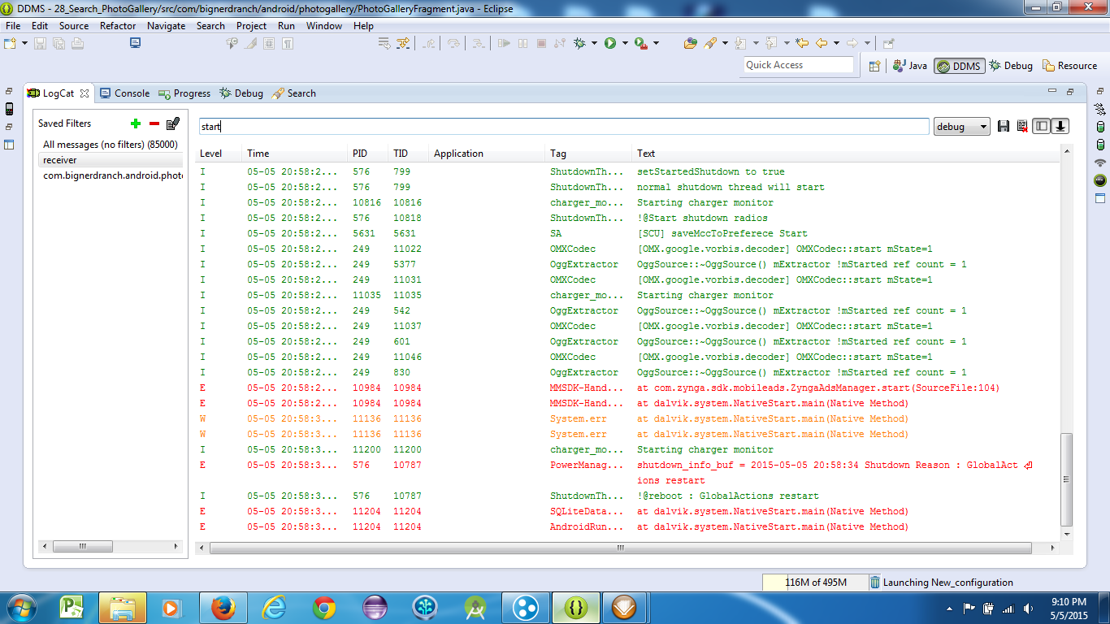

Question 1:

No, it ran just long enough to start its background service.

|  |  |  |
| --- | --- | --- |
| **Steps** | **Expected Result** | **Your result** |
| Run as Android. | Emulator starts and installs the application. | It works. |
| Launch PhotoGallery. | Thumbnails start to download. | It works. |
| Turn on polling. | Background service starts. | Indeed. |
| Close the emulator. | The application shuts down. | Correct. |
| Start the device from the Android Virtual Device Manager. | Emulator starts. | Correct. |
| Wait a few minutes and check for notifications. | There should be a notification. | Works as expected. |
| Launch PhotoGallery by clicking the notification. | PhotoGallery should launch and at least one new picture should display. | Working. |
| Turn off poling. | Should quit sending notifications. | Works as expected. |
| Close the emulator. | It should shutdown. | It works. |
| Start the device from the Android Virtual Device Manager. | Emulator starts. | It works. |
| Wait a few minutes and check for notifications. | There should not be any notifications. | There are no new notifications. |

Question 2:

I called it in the onPause() handler so that it will unregister the receiver when the app is paused.

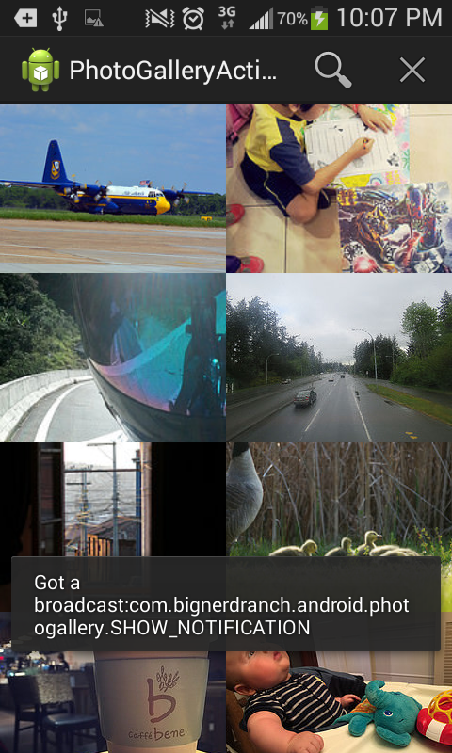

Question 3:

The system only grants permission if the app is signed with the same certificate as the declaring application.

Question 4:

The broadcast occurs as the Application is being sent through the onPause() and onDestroy() steps. The broadcast may be destroyed before it receives feedback.